Linux Zip and Unzip Files
Dan Richter
20 Sep 2020

I know we had taken a look at how to use TAR a few articles ago. Well, there is another common archive utility used, and that is the ZIP file. Let’s take a look at what we can do with a zip file.

First, we need to make sure we have the utilities installed on our computer. If you are on a Debian based system:

‘sudo apt install zip unzip’
or
‘sudo apt-get install zip unzip’

If you are running on an Arch based system, with pacman:

‘sudo pacman -Syu zip unzip’

Now, we will take a look at how to do this through the terminal, and after we can look at how to do it through the gui. I think if you understand something being done manually, you can appreciate it when doing it through a gui.

Let’s say you have some text files that you would like to email to someone. Instead of adding each of the text files to the email, you could archive them into a zip file, and just work with one file. In this example, we want to archive the file ‘report.txt’ into an archive called ‘reports.zip.

zip <archivename> <filestoadd>
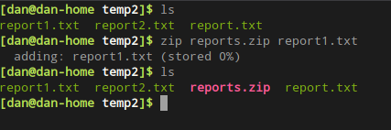
You’ll see we took the file ‘report.txt’ and created the archive ‘reports.zip’, containing ‘report.txt’. While this doesn’t really save us any time or space, let’s add the other report files to the archive.

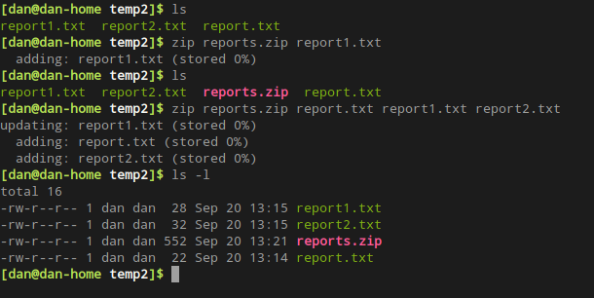
There. Now the reports.zip file contains all three of the report text files. But, you just found another report that you need to add to the archive. Now what? Well, there is an option with zip that will allow you to just update the archive with another file.
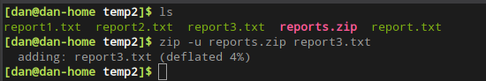
With the ‘-u’ switch, you can just update the archive.

So, what all do we have in this archive now? Is there a way to find out? Yes, we can list the files contained in the archive.
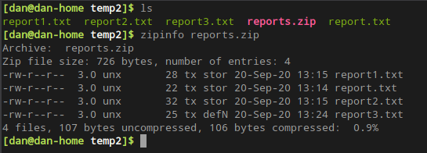
There is an program called ‘zipinfo’ that comes with zip, which will give you information about your zip archive. In this case, you can see there are four files in this archive, and gives you all of the information about those files.

If you would like to archive all of the files in a particular directory into an archive, this can be done with the use of wildcards. The ‘*’ is the common wildcard, which Linux will expand to mean anything.

In the following example, I have removed the archive we made previously, and re-archived using the ‘*’ wildcard instead of typing in all of the text file names.
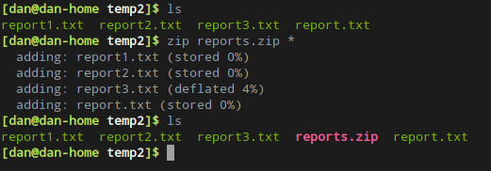
This just made life a little easier. If there were other files in that directory that I did not want to include in the archive, I could have typed ‘zip reports.zip *.txt’, as this would have only included the text files.

Now, if we want to remove a file from the archive, we could type in ‘zip -d reports.zip report.txt’.
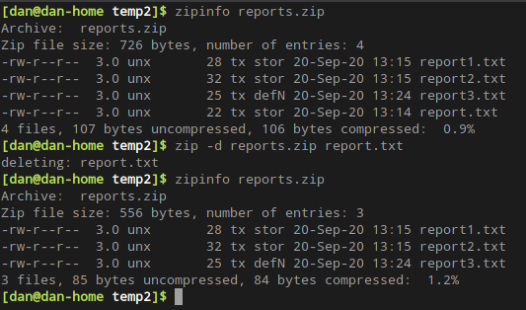
You’ll notice that the file ‘report.txt’ was successfully removed from the archive.

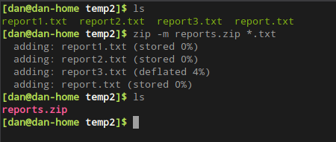
Now, if we want to archive these text files, but after they are archived, we no longer need the text files. We could have ‘zip’ remove them after they are zipped.

You’ll notice it removed all of the text files after creating the reports.zip file.

Ok, so now we have created zip files, but what do we do with them? Let’s take a look at ways to unzip our… files. :)

If you received this ‘reports.zip’ file from a co-worker, you might want to see what’s inside of it.
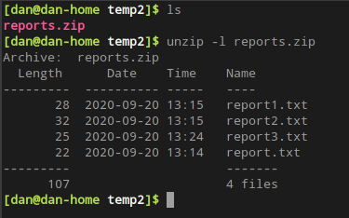
This is similar to using zipinfo to view the archive, but doesn’t give as much information. This is just a down-and-dirty way to viewing the contents before doing anything with the archive. If you do want to view detailed information about the archive.
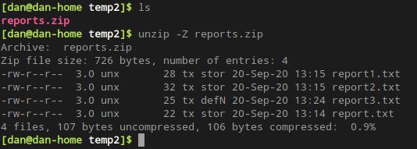
Now that you’ve confirmed the contents of the archive are what you were waiting for, let’s go ahead and unarchive this zip file, so we can work with the contents.

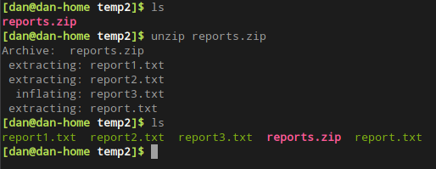
What if we really wanted to unarchive these files into another directory? Well, there’s a way to do that as well.
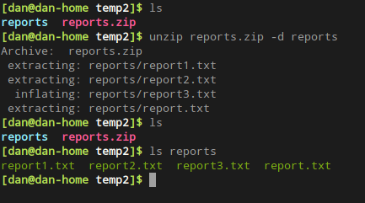
Or, what if we only want to unarchive the report2.txt file, but not the others.
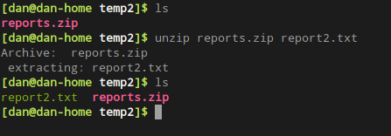
As you can see, it is actually pretty easy to work with ‘zip’ files from the command line. However, what if you are already in your file manager and would like to work with them.

Again, keep in mind, this is using Manjaro, with caja as my file manager. Things may look different on your system, but should be similar.

Here is our files that we have been using in this article.
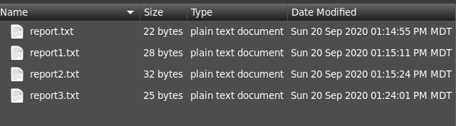
We want to create an archive containing these files, as we did from the command line. All we have to do, is click on one of the files, and hit ‘<CTRL>-A’, which will select all of the files (icons) currently on the screen.
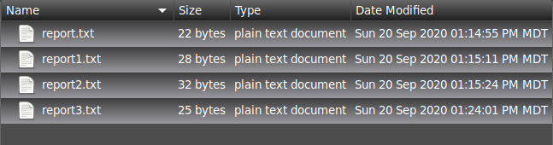
We then Right-Click on those files, and select ‘Compress’.
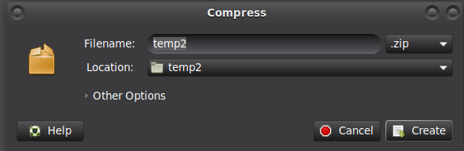
Here, we can tell it what name we would like the archive to have, along with what type of archive we would like to create. Let’s change the name to reports, leave it as a zip file and create it.

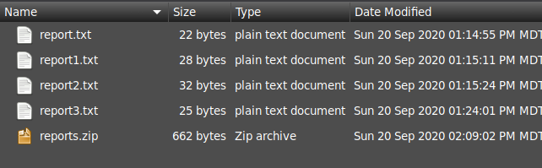
From that compress window, we could have changed it from ‘zip’ to ‘tar’, etc.

To unarchive this zip file, we can Right-Click on it and chose ‘Extract Here’ if we want it in this directory, or select ‘Extract To..’ if we want to chose a different directory to store the files in.

This was just a relatively quick overview of the ‘zip’ functions within Linux. They are similar to Windows, but everything has to be just a little different, right? ;)

